A000-Afr-D R Congo-Mbuti Bark Cloth-Forest Gathering Locations-Early 20th c

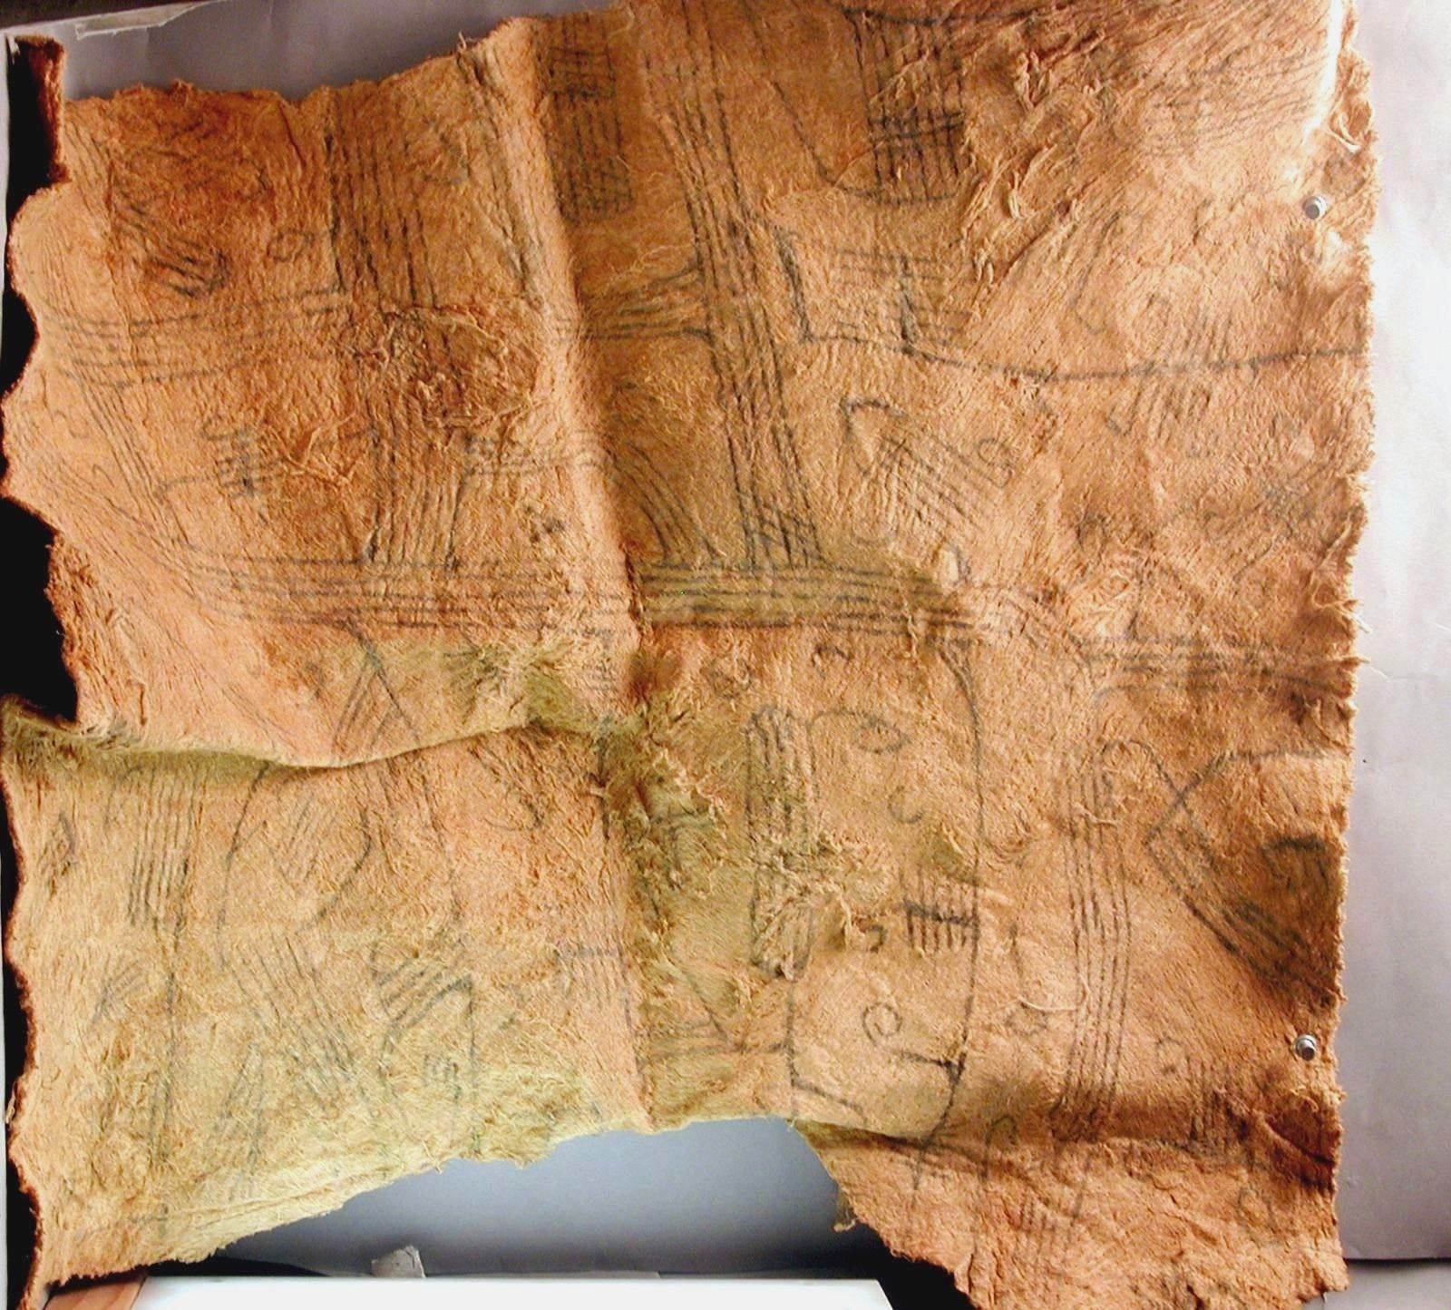

Fig. 1. Mbuti Bark cloth, early 20th c

